PROTOCOL:

Recording example subject #9:

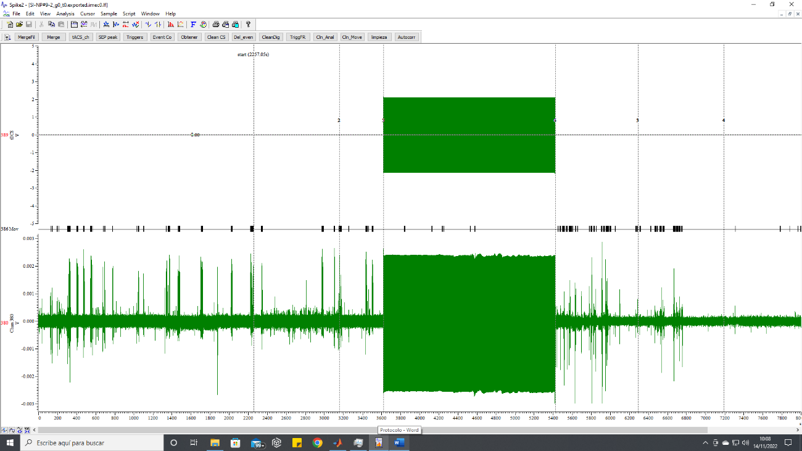

tACS

Movement

Recording channel

PRE

DUR

POST

For data analysis, 900 seconds of the pre (PRE) period before tACS stimulation and 900 seconds of the post (POST) period are exported for the 384 recording channels. It is intended that these periods of time are as clean of movement as possible. Likewise, the same time periods are exported for the movement channel (which indicates when the mouse moved), here we also export the movement data during the tACS application (DUR, 30 minutes).

The sampling rate during recording was 2500 Hz and the signal amplification was 250. Data are in volt (V) and the amplification gain has already been corrected.

The data is saved as .mat since the analyzes are being carried out with Matlab. We send you 2 “cell” type matrices. The ***Suj9*** matrix contains the recording data of the 384 channels. The first cell (Suj9{1,1}) contains the data for the PRE period and the second cell (Suj9{2,1}) contains the data for the POST period. On the other hand, the ***mov*** matrix contains the movement data (in seconds) for the three periods. The times for the PRE period are in the first cell, those for the DUR period in the second cell, and those for the POST period in the third.